Course Assignment Management

Initial Requirements Specification
(IEEE Guidelines Used)
Rough Version

February 8, 2015

Shelley Dogra

Computer Science Project
Lewis University
Dr. Cindy Howard
Spring 2015

Table of Contents
Table of Contents ii
Revision History ii
1. Introduction 1
1.1 Purpose 1
1.2 Document Conventions 1
1.3 Intended Audience and Reading Suggestions 1
1.4 Product Scope 1
1.5 References 1
2. Overall Description 2
2.1 Product Perspective 2
2.2 Product Functions 2
2.3 User Classes and Characteristics 2
2.4 Operating Environment 2
2.5 Design and Implementation Constraints 2
2.6 User Documentation 2
2.7 Assumptions and Dependencies 3
3. External Interface Requirements 3
3.1 User Interfaces 3
3.2 Hardware Interfaces 3
3.3 Software Interfaces 3
3.4 Communications Interfaces 3
4. System Features 4
5. Other Nonfunctional Requirements 4
5.1 Performance Requirements 4
5.2 Safety Requirements 5
5.3 Security Requirements 5
5.4 Software Quality Attributes 5
5.5 Business Rules 5
6. Other Requirements 5
Appendix A: Glossary 5
Appendix B: Analysis Models 5
Appendix C: To Be Determined List 6

Revision History
Name | Date | Reason For Changes | Version
Shelley Dogra | February 8, 2015 | Initial Rough Draft | Version 1.0

Introduction

Purpose
This software application will be written for students who want to manage their assignments by priority of how each assignment will affect their final GPA for the Semester.

Document Conventions
TBD

Intended Audience and Reading Suggestions
This document is for the overseer and future software developer who will be involved with this product. It could also be beneficial for potential users of the application.

Product Scope
The vision of this application is for the students who are on the go and can use this application on their smart phones to track their assignments and view what assignment deems most attention at that given time. The priority will be based on the weight of the assignment and how it measures against other assignments as the deadline approaches.

References
TBD

Overall Description

Product Perspective
This application will be developed as self-contained software. The database will also be sandboxed and be retained within the application.

Product Functions
- Student can enter all of the courses for the semester
  - Course Name
  - Course Number
  - Credit Hours
- For each course Point distribution and weight can be enter for each type of assignment
  - Example: Homework, Quizzes, Test, Attendance, etc.
- For each course assignments will be entered
  - Assignment name
  - Assignment points possible
  - Due Date
- Feedback to the student
  - Calculated priority assignments
  - Due Dates
  - Suggested assignment to focus on that time

User Classes and Characteristics
- Student
  - Overall GPA
  - Required percentage (Example: 90%)
  - Courses
  - Semester
- Courses
  - Credit hours (weight)
  - Assignments
  - Description
- Assignments
  - Weight
  - Due Date
  - Type
  - Points Possible
  - Points Received

Operating Environment
The environment will be iOS version 8 for the iPhone 6 (4.7 inch screen) and will use core data for data storage and access.

Design and Implementation Constraints
- Apple guidelines
- Screen Size and resolution
- Language: Objective-C and some Swift
  - Design Patterns: TBD
- Database: Core Data

User Documentation
TBD

Assumptions and Dependencies
There will be an assumption of the part of the user to input the right information (assignment weight, due dates, etc.) as it could affect the output of the application.

External Interface Requirements

User Interfaces
The User Interface will all be through touch screen using the generic UI object available for iOS 8 in Xcode version 6.1. The screen constraint will be for 4.7” screen using standard UI buttons and table views and navigation elements for the appropriate scene. Error Messages can be handled by alert pop up views that would require user intervention.

Hardware Interfaces
Other than the phone itself there will not be any other hardware interface requirements.

Software Interfaces
TBD

Communications Interfaces
TBD

System Features

TBD

Other Nonfunctional Requirements

Performance Requirements
- Proper Memory Management
- TBD

Safety Requirements
TBD

Security Requirements
TBD

Software Quality Attributes
TBD

Business Rules
TBD

Other Requirements
TBD
Appendix A: Glossary
- iOS – Apple operating system for iPhones, iPads and iPods.
- Core Data – Database system designed to be a part of Xcode
- Xcode – IDE for developing for Mac and iOS
- UI – User Interface
Appendix B: Analysis Models
- Data Flow Diagram
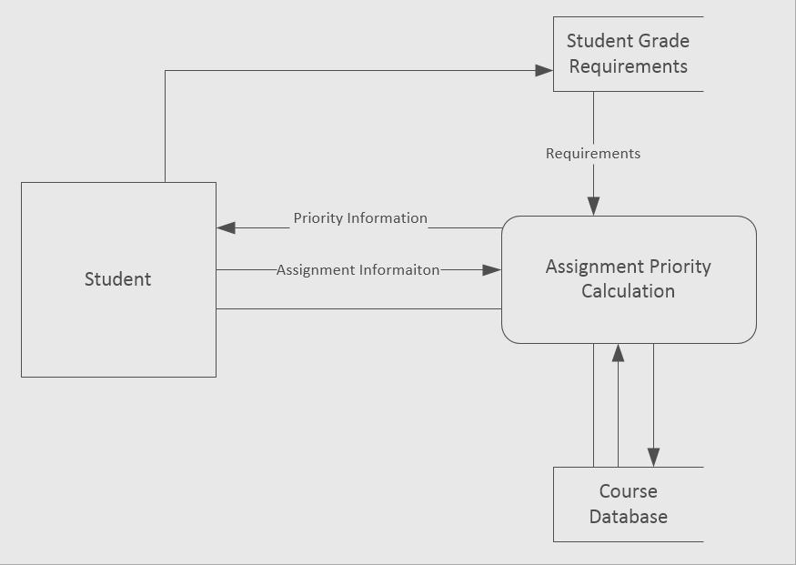
2. Entity Relationship Diagram
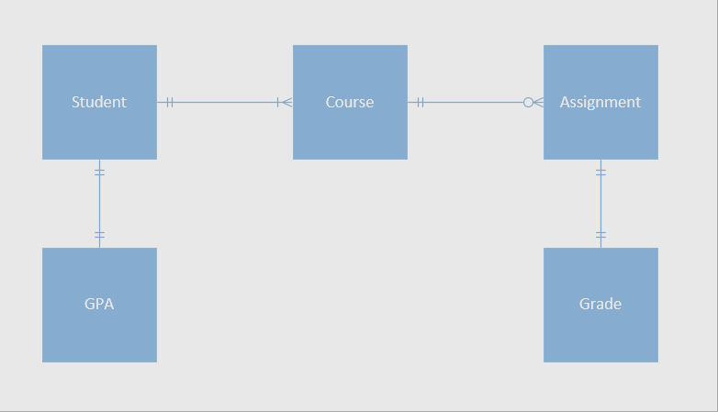
Appendix C: To Be Determined List
- Document Conventions
- References
- User Documentation
- Software Interfaces
- Communication Interfaces
- System Features
- Other Nonfunctional Requirements
- Other Requirements
- Further Analysis Models

